**Python TRAINING**

**Task – 9(31th July)**

**SHAFALI GUPTA**

1. **Download PyCharm and make a project with any name.**

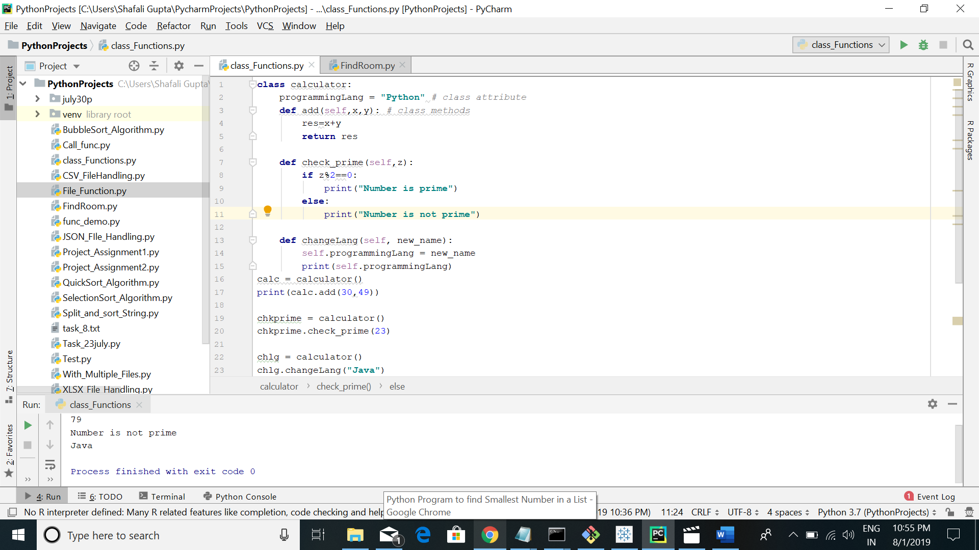

1. **Find out the room Number.**

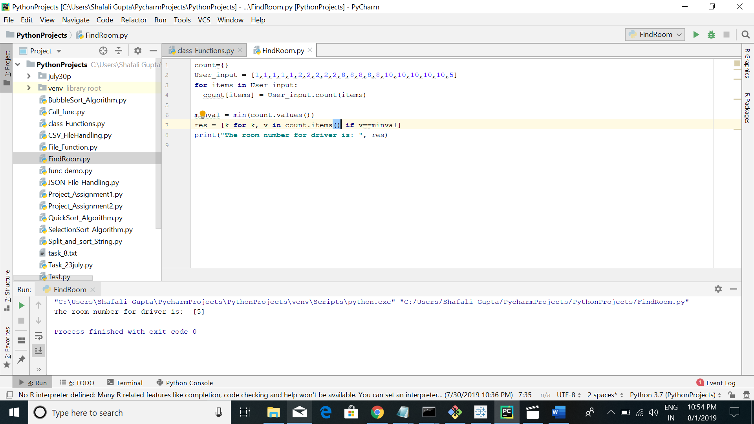

1. **Push your code to GitHub Repository.**

**Ans:-** I attached the screen shot above and upload the source code on GitHub Repository. Here is link for Django repository- <https://github.com/shafaligupta/PythonTraining/tree/master/Django>